Exp1:
A1=[-1.5 -2;1 0];
B1=[0.5;0];
C1=[0 1];
D1=5;
sys1= ss (A1,B1,C1,D1,'TimeUnit','minutes','InputUnit','minutes');
step(sys1)
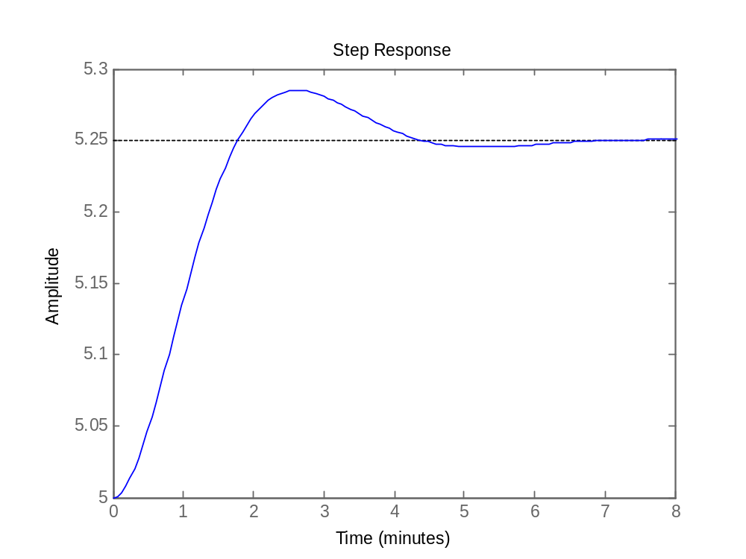

exp2:
function dx=sys(t,x)
A=[0 1;-2 3]; B=[0;1];K=[-1 -1];
u=K*x
dx=A*x+B*u;
end

tspan=[0 10];
iniCon=[1;-1]
[t,y]=ode45(@sys,tspan,iniCon);
plot(y)
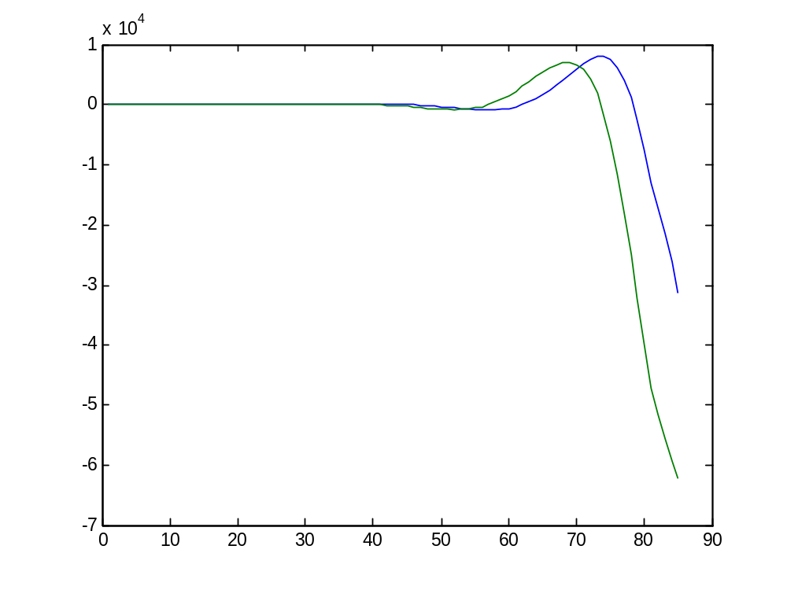
exp3:
function dx = bacteriadiff(t,x)
%My simple Differential Equation

b=1;
p=0.5;

dx =b*x - p*x^2;
clear
clc

tspan=[0 1];
x0=100;

[t,y]=ode45(@bacteriadiff, tspan,x0);
plot(t,y)

[t,y]
plot(y)
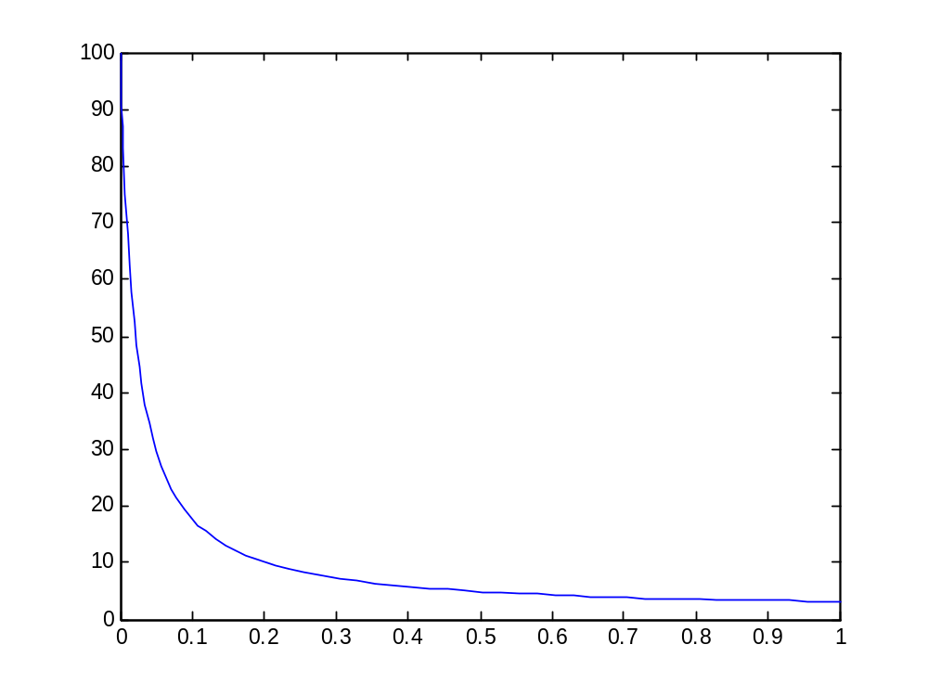

Exp4
function xdot=r2dof(t, x, spec)
xdot=zeros(8,1)
%robot specification
M1=spec(3);
M2=spec(4);
L1=spec(1);
L2=spec(2);
g=9.8;
% Inertia Matrix
b11=(M1+M2)*L1^2+M2*L2^2+2*M2*L1*L2*cos(x(4));
b12=M2*L2^2+M2*L1*L2*cos(x(4));
b21=M2*L2^2+M2*L1*L2*cos(x(4));
b22=M2*L2^2;
Bq=[b11 b12;b21 b22];
%C matrix
c1=-M2*L1*L2*sin(x(4))*(2*x(5)*x(6)+x(6)^2);
c2=-M2*L1*L2*sin(x(4))*x(5)*x(6);
Cq=[c1;c2];
%gravity matrix
g1=-(M1+M2)*g*L1*sin(x(3))-M2*g*L2*sin(x(3)+x(4));
g2=-M2*g*L2*sin(x(3)+x(4));
Gq=[g1;g2];
%couple
f1=0;
f2=0;
fhat=[f1;f2];
%F=Bq*fhat;
xdot(1)=x(3);
xdot(2)=x(4);
xdot(3)=x(5);
xdot(4)=x(6);
q2dot=inv(Bq)*(-Cq-Gq+fhat);
xdot(5)=q2dot(1);
xdot(6)=q2dot(2);
xdot(7)=fhat(1);
xdot(8)=fhat(2);
%xdot=[x(3);x(4);x(5);x(6);q2dot(1);qdot(2);fhat(1);fhat(2)];

______________

close all
clear all
clc
%Initialisation
th_int=[-pi/2 pi/2];
%initial position
x0=[0 0 th_int 0 0 0 0];
Ts=[0 20];
%Robot specifications
L1=1;
L2=1;
M1=1;
M2=1;
spec=[L1 L2 M1 M2];
%ODE solving
[T,X]=ode45(@(t,x) r2dof(t,x,spec),Ts,x0);
%output
th1=X(:,3);
th2=X(:,4);

x1=L1.*sin(th1);
y1=L1.*cos(th1);
x2=L1.*sin(th1)+L2.*sin(th1+th2);
y2=L1.*sin(th1)+L2.*cos(th1+th2);
plot(T,th1)
figure
plot(T,th2)

d=2;
j=1:d:length(T);
% generation
figure
for i=1:length(j)-1
hold off
plot([x1(j(i)) x2(j(i))], [y1(j(i)) y2(j(i))],'o',[0 x1(j(i))],[0 y1(j(i))],'k',[x1(j(i)) x2(j(i))],[y1(j(i)) y2(j(i))],'k')
title('Mention of 2DOF Roboti Arm')
xlabel('x')
ylabel('y')
axis([-3 3 -3 3]);
grid
hold on
MM(i)=getframe(gcf);
end
drawnow
% exporting to 'mpg'movie
mpgwrite(MM,'RGB','2DOF_rob.mpg')

[T,X]=ode45(@(t,x) r2dof(t,x,spec),Ts,x0);
th1=X(:,3);
th2=X(:,4);

x1=L1.*sin(th1);
y1=L1.*cos(th1);
x2=L1.*sin(th1)+ L2.*sin(th1+th2);
y2=L1.*cos(th1)+L2.*cos(th1+th2);
plot(T,th1)
figure
plot(T,th2)

d=2;
j=1:d:length(T);

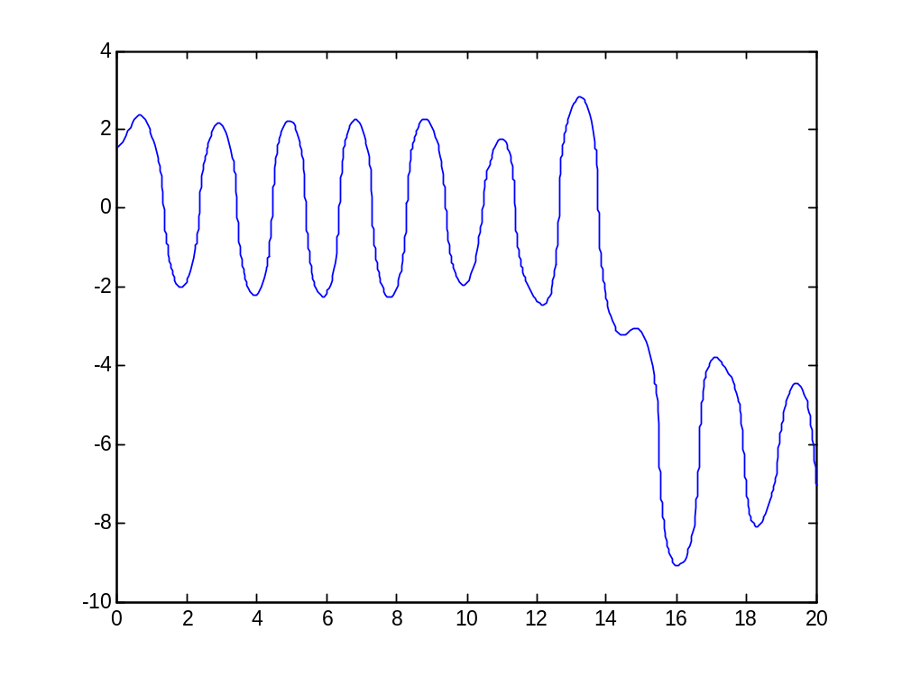
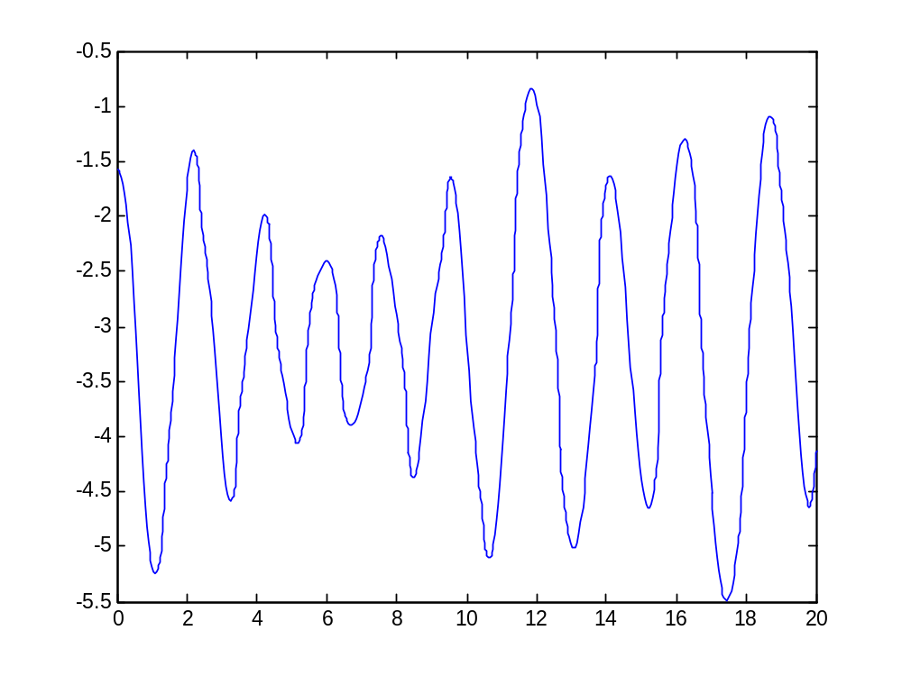
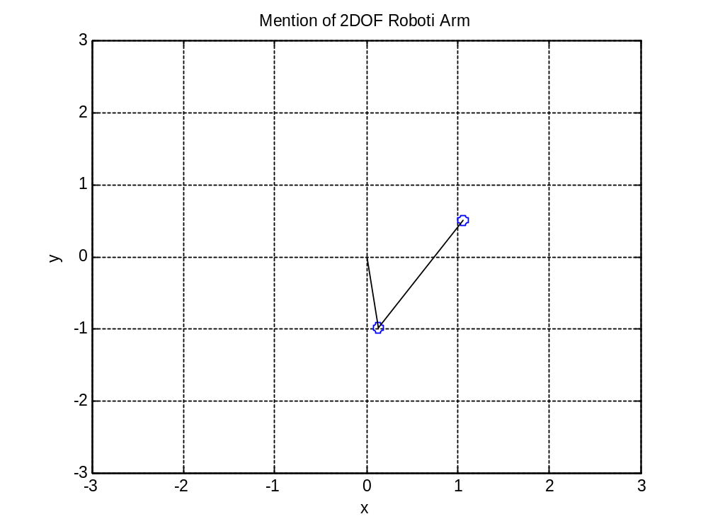
function xdot=r2dof(t, x,ths, spec,Kpid)
xdot=zeros(8,1)
%robot specification
M1=spec(3);
M2=spec(4);
L1=spec(1);
L2=spec(2);
g=9.8;
th1s=ths(1);
th2s=ths(2);

% Inertia Matrix
b11=(M1+M2)*L1^2+M2*L2^2+2*M2*L1*L2*cos(x(4));
b12=M2*L2^2+M2*L1*L2*cos(x(4));
b21=M2*L2^2+M2*L1*L2*cos(x(4));
b22=M2*L2^2;
Bq=[b11 b12;b21 b22];
%C matrix
c1=-M2*L1*L2*sin(x(4))*(2*x(5)*x(6)+x(6)^2);
c2=-M2*L1*L2*sin(x(4))*x(5)*x(6);
Cq=[c1;c2];
%gravity matrix
g1=-(M1+M2)*g*L1*sin(x(3))-M2*g*L2*sin(x(3)+x(4));
g2=-M2*g*L2*sin(x(3)+x(4));
Gq=[g1;g2];
%PID PARAMETRES
Kp1=Kpid(1);
Kd1=Kpid(2);
Ki1=Kpid(3);
Kp2=Kpid(4);
Kd2=Kpid(5);
Ki2=Kpid(6);
%couple
f1=Kp1*(th1s-x(3))-Kd1*x(5)+Ki1*(x(1));
f2=Kp2*(th2s-x(4))-Kd2*x(6)+Ki2*(x(2));
fhat=[f1;f2];
F=Bq*fhat;
xdot(1)=(th1s-x(3));
xdot(2)=(th2s-x(4));
xdot(3)=x(5);
xdot(4)=x(6);
q2dot=inv(Bq)*(-Cq-Gq+F);
xdot(5)=q2dot(1);
xdot(6)=q2dot(2);
xdot(7)=F(1);
xdot(8)=F(2);
%xdot=[x(3);x(4);x(5);x(6);q2dot(1);qdot(2);fhat(1);fhat(2)];
close all
clear all
clc
%Initialisation
th_int=[-pi/2 pi/2];
ths=[pi/2 -pi/2];
%initial position
x0=[0 0 th_int 0 0 0 0];
Ts=[0 20];
%Robot specifications
L1=1;
L2=1;
M1=1;
M2=1;
spec=[L1 L2 M1 M2];
%ODE solving
Kp1=15;
Kd1=7;
Ki1=10;
Kp2=15;
Kd2=15;
Ki2=20;
Kpid=[Kp1 Kd1 Ki1 Kp2 Kd2 Ki2];
[T,X]=ode45(@(t,x) r2dof(t,x,ths,spec,Kpid),Ts,x0);
%output
th1=X(:,3);
th2=X(:,4);
a=X(:,5);

F1=diff(X(:,7))./diff(T);
F2=diff(X(:,8))./diff(T);
tt=0:(T(end)/(length(F1)-1)):T(end)

x1=L1.*sin(th1);
y1=L1.*cos(th1);
x2=L1.*sin(th1)+L2.*sin(th1+th2);
y2=L1.*sin(th1)+L2.*cos(th1+th2);
plot(T,a)
figure
plot(T,ths(1)-th1)
figure
plot(tt,F1)
figure
plot(tt,F2)
d=2;
j=1:d:length(T);
% generation
figure
for i=1:length(j)-1
hold off
plot([x1(j(i)) x2(j(i))], [y1(j(i)) y2(j(i))],'o',[0 x1(j(i))],[0 y1(j(i))],'k',[x1(j(i)) x2(j(i))],[y1(j(i)) y2(j(i))],'k')
title('Mention of 2DOF Roboti Arm')
xlabel('x')
ylabel('y')
axis([-3 3 -3 3]);
grid
hold on
MM(i)=getframe(gcf);
end
drawnow
% exporting to 'mpg'movie
mpgwrite(MM,'RGB','2DOF_rob.mpg')

[T,X]=ode45(@(t,x) r2dof(t,x,spec),Ts,x0);
th1=X(:,3);
th2=X(:,4);

x1=L1.*sin(th1);
y1=L1.*cos(th1);
x2=L1.*sin(th1)+ L2.*sin(th1+th2);
y2=L1.*cos(th1)+L2.*cos(th1+th2);
plot(T,th1)
figure
plot(T,th2)

d=2;
j=1:d:length(T);

